**Module 10 – Single Page Application framework – React**

**10.ReactJS-HOL**

**Define JSX**  
JSX (JavaScript XML) is a syntax extension that allows writing HTML-like code inside JavaScript. It's used in React to describe what the UI should look like.

**Explain ECMA Script**  
ECMAScript (ES) is the scripting language standard on which JavaScript is based. ES6 (ECMAScript 2015) introduced major features like let, const, arrow functions, classes, and modules.

**React.createElement()**  
It’s the function that JSX gets compiled into. It creates a virtual DOM node.

const heading = React.createElement('h1', null, 'Hello!');

**Creating React nodes with JSX**  
Instead of using React.createElement(), you can write:

const heading = <h1>Hello!</h1>;

**Rendering JSX to the DOM**  
Use ReactDOM.render() or createRoot().render() to render JSX into a browser DOM node.

ReactDOM.createRoot(document.getElementById('root')).render(<App />);

**JavaScript expressions in JSX**  
Use {} to embed JavaScript in JSX.

<h2>{office.name}</h2>

**Inline CSS in JSX**  
You can add CSS using the style attribute with a JS object:

<p style={{ color: 'red' }}>Text</p>

**Structure:**

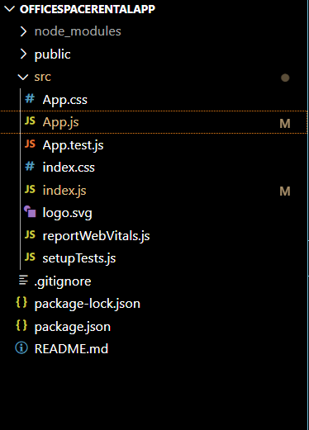

**App.js:**

import React from 'react';

function App() {

  const office = {

    name: "DBS",

    rent: 50000,

    address: "Chennai",

    image: "https://images.unsplash.com/photo-1615874959474-d609969a20ed?auto=format&fit=crop&w=800&q=60"

  };

  // Inline style object based on rent value

  const rentStyle = {

    color: office.rent < 60000 ? 'red' : 'green',

    fontWeight: 'bold'

  };

  return (

    <div style={{ textAlign: 'center', marginTop: '30px', fontFamily: 'Arial' }}>

      {/* Heading */}

      <h1>Office Space , at Affordable Range</h1>

      {/* Image */}

      <img

        src={office.image}

        alt="Office Space"

        style={{ width: '400px', height: '250px', objectFit: 'cover', margin: '20px 0' }}

      />

      {/* Office Details */}

      <div style={{ textAlign: 'left', margin: '0 auto', width: '400px' }}>

        <h2>Name: {office.name}</h2>

        <p style={rentStyle}>Rent: Rs. {office.rent}</p>

        <p>Address: {office.address}</p>

      </div>

    </div>

  );

}

export default App;

**index.js:**

import React from 'react';

import ReactDOM from 'react-dom/client';

import App from './App';

const root = ReactDOM.createRoot(document.getElementById('root'));

root.render(<App />);

**Output:**

